 | Patient Newsletter  SUMMER  2023 |  | 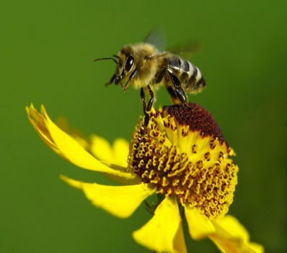
Dear Patients, this is our latest news update. After a mixed summer and another extremely busy time in surgery, we have a few things to tell you about in this issue. |  | WELCOME to Mohanned, our new clinical pharmacist. He will be working with LMC on Mondays & Tuesdays. He is currently still learning the ropes but will be up and running soon.
SHINGLES INJECTION  The shingles vaccine is changing from September, and you could be eligible. Please see the information and eligible criteria below or ask at reception for more information.  UKHSA_12644_A5_Shingles_8pp_leaflet_12 WEB (1).pdf  UKHSA_12644_Shingles_Eligibility_table_poster_2023_12 landscape WEB.pdf  FLU SEASON  The flu season is nearly upon us. Our flu vaccines are being delivered early October and our weekend clinic date is on Saturday 21st October. Appointments are already starting to be filled.  INFECTION CONTROL  Last month we had our infection control audit and achieved 93%. Well done to all involved. We have created our action plan and we are starting to complete all our actions to improve on this going forward.  BP AWARENESS WEEK 5th – 11th September 2023  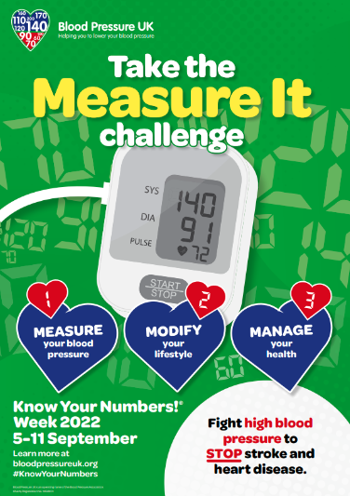 |  | FRIENDS AND FAMILY FEEDBACK  I would like to give you some positive patient feedback. On Tuesday 01/08/23 at 16.50, my son had an appointment. I did the E-Consult the day before, and within a couple of hours a very friendly member of your team rang me to arrange a face-to-face appointment the day after. The following day, we were seen within minutes of arrival and the G.P included both myself and my 16-year-old son in the conversation regarding his health issue. She was patient, gave time to listen to concerns and gave him a treatment plan going forward. I can't fault the service we received. In addition to this, I would also like to say, the receptionist on duty the day of our face-to-face consultation was also lovely, and your surgery is spotless. I work for the N.H.S at Warrington and Halton Hospital and know the difficulties we face. We often don't get the recognition we deserve. Please will you share my positive feedback with your team because they need to know they do an amazing job😀.  PATIENT PARTICIPATION GROUP  Our Patient Participation Group is hoping to form again in Autumn. We are looking for new members to join us. Please email cmicb-war.latchfordmc@nhs.net

